To: ANNE DODGE, ESU

From: Shalini Ganendra

March 5, 2008 - by email

BORNEO – A BOWL OF WIND AND WATER EXHIBITION
March 17 –April 31

Re: Placement of Photographs

WALL 1 (11’ W) ( all photographs hung in one row, eye level) – nearest to Entrance

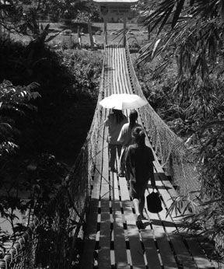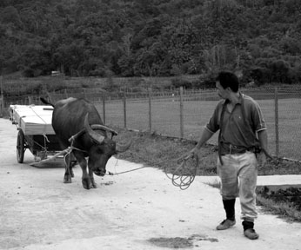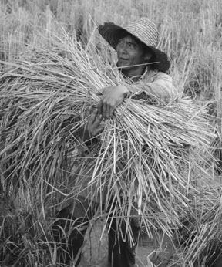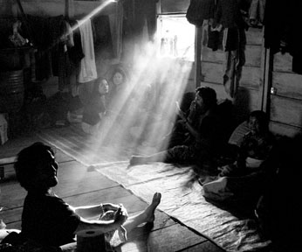

WALL 2 (4’ W) (vertical hung, one above the other. Vertical image at top, horizontal at bottom)

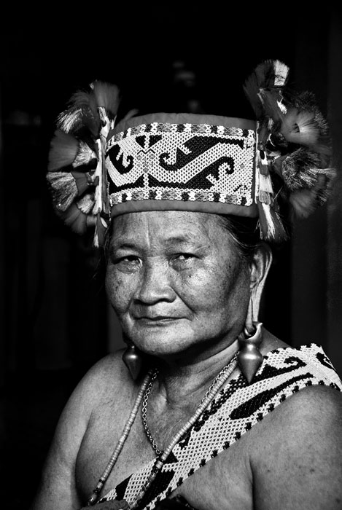
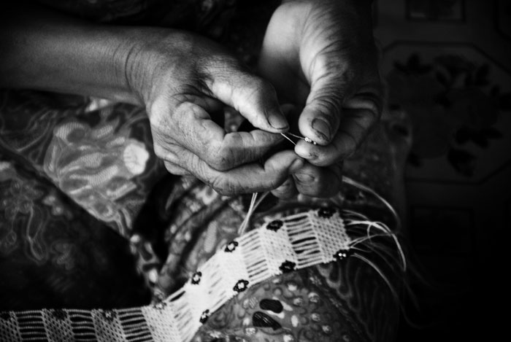

WALL 3 (4’ W) ( vertically hung, one above the other)
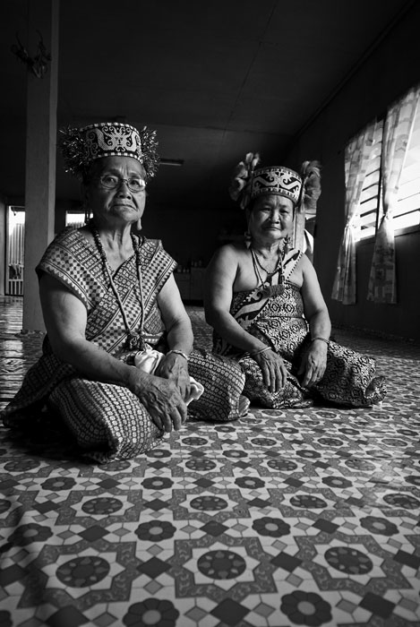
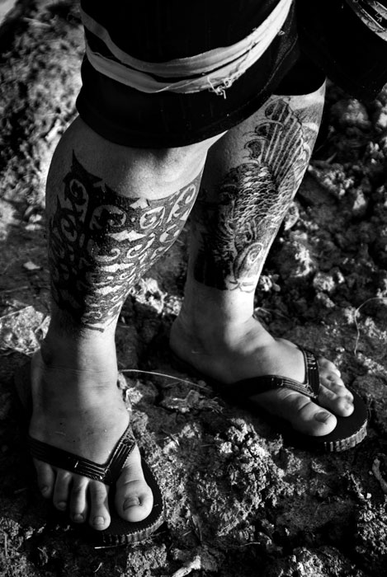

WALL 4 (9’ W) ( all photographs hung in one row, eye level) – (nearest to Garden Exit)

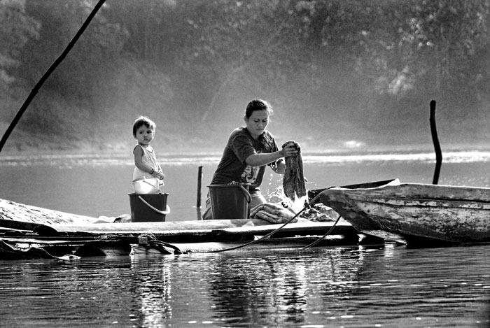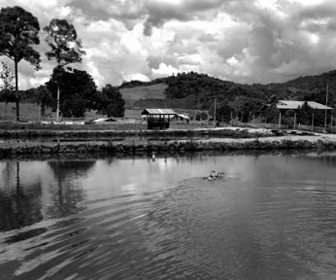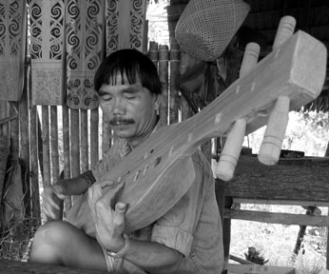

Other side:

WALL 5 (10.5’ W) ( all photographs hung in one row, eye level) – (nearest to Garden Exit)

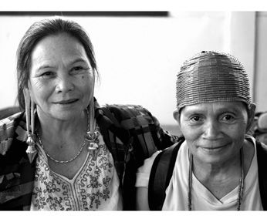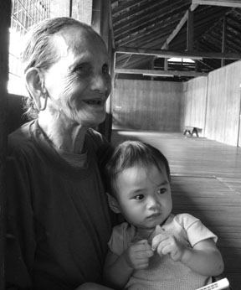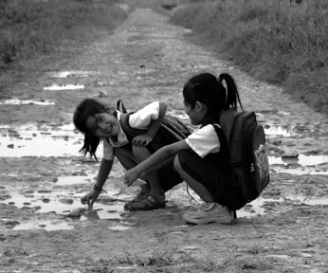

WALL 6 (9’ W) ( all photographs hung in one row, eye level) – (nearest to Entrance)

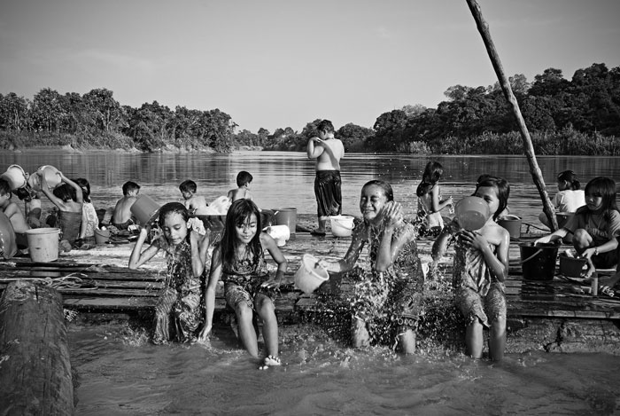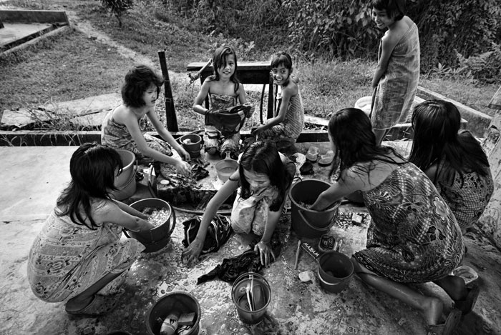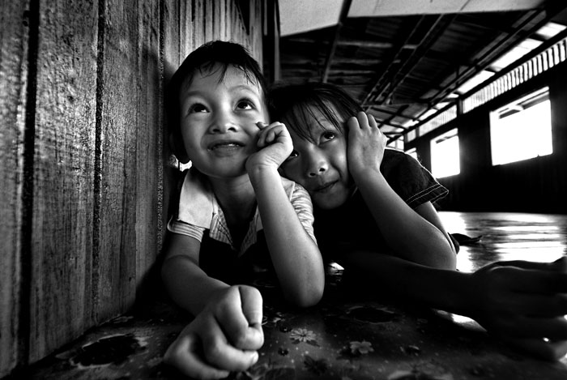

BORNEO – A BOWL OF WIND AND WATER
SHALINI GANENDRA FINE ART
ESU USA Headquarters, New York, New York
March 17 – April 30, 2008

SC SHEKAR: Edition 1/10, 8” x 10”, Digital Archival Matt Print

I. Berawan Woman
1.
2.
3.
4.
5.
6.
7.
8.
9.
10.

II. Berawan Women
1.
2.
3.
4.
5.
6.
7.
8.
9.
10.

III. Iban Farmer
1.
2.
3.
4.
5.
6.
7.
8.
9.
10.

IV. Berawan Children
1.
2.
3.
4.
5.
6.
7.
8.
9.
10.

V. Iban Children, Lower Baram
1.
2.
3.
4.
5.
6.
7.
8.
9.
10.

VI. Iban Mother & Daughter
1.
2.
3.
4.
5.
6.
7.
8.
9.
10.

VII. Berawan Longhouse, Lower Baram
1.
2.
3.
4.
5.
6.
7.
8.
9.
10.

VIII. Penan Native Craftswomen
1.
2.
3.
4.
5.
6.
7.
8.
9.
10.

IX. Iban Children I
1.
2.
3.
4.
5.
6.
7.
8.
9.
10.

BOB TEOH : Edition 1/10 (1-5 only for ESU show), 8” x 10” Lamda Print

I. Native- Chinese Farm, Long Banga, 2008
1.
2.
3.
4.
5.
.

II. Lun Bawang Trader, Ba’ Kelalan, 2008
1.
2.
3.
4.
5.

III. Kelabit Ladies, 2008
1.
2.
3.
4.
5.

IV. Kelabit Schoolgirls, Bario, 2008
1.
2.
3.
4.
5.

V. Keeper of Ngorek Songs, Long Semiang, 2008
1.
2.
3.
4.
5.

VI . Saban Villagers, Long Banga, 2008
1.
2.
3.
4.
5.

VII. Kenyah Woman With Grandchild, Long Tungan, 2008
1.
2.
3.
4.
5.

VIII. Harvesting Bario Rice, Long Semanda, 2008
1.
2.
3.
4.
5.

IX. Morning Player, Mount Murud, 2008
1.
2.
3.
4.
5.

US $ 700 each print including delivery. Best to arrange collection at ESU.
Crossed cheque payment in name of: DENNIS GANENDRA
Alice Boyne wrote:
Shalini,
I’m returning the flyer to you with a few changes. I am concerned a bit about the dates as 1) we would probably want to start the exhibit on Monday, March 17 so as to coincide with Asian Contemporary Art Week. We would then be sure that we had someone here each night that week after the work day to accommodate anyone coming by. The exception is that Friday, March 21 as that is Good Friday which is generally a kind of religious holiday and, while we could have people during the day, we wouldn’t be able to keep the place open late. 2) we can have the works up until the 30th but we couldn’t arrange to have someone here every work night for those 6 weeks although we probably could by appointment if that is helpful.

We will have a reception here on Thursday, March 20th. It’s already on Bill Miller’s calendar and we will work on a guest list. We’ve alerted the Malaysian consulate but will get a formal invitation off if you confirm that this is a good night for an event.

More later

Alice

Alice Boyne
President & Executive Director
The English-Speaking Union of the United States
144 East 39th Street
New York NY 10016
Tel 212 818 1200
Fax 212 867 4177
E-mail aboyne@esuus.org

From: Shalini Ganendra SGFA [mailto:stag@tm.net.my]
Sent: Wednesday, February 20, 2008 10:47 PM
To: Alice Boyne
Subject: Re: Bario - Photography Show March - April 2008, ESU USA

Dear Alice:
Please view attached. We would like to send to our press contacts. In particular, do the dates work for you - March 20 - April 30. Any unsold works would be packed and returned (by UPS courier on our account).
Exciting.
Shalini
Bario- A Bowl of Wind and Water

Bob Teoh’s adventure of more than two years in the inner regions of Sarawak, have produced images that speak to us in many ways, not least of which is to introduce communities that are less familiar because of their physical and cultural distances from urban centres. The ethnographic nature of these photographs serve to document a journey, both physical and spiritual, of one man, in this region between two rivers. We are fortunate to be able to follow him through the lens.

Shalini Ganendra Fine Art is delighted to curate and present this select exhibition of 15 works, Bario- A Bowl of Wind and Water, as a photographic essay which observes indigenous communities of Bario, Sarawak. The collaboration with the English Speaking Union of the United States is essential because of its involvement with educational programs in this area.

The English Speaking Union of Malaysia initiated a program linking a school in Bario (SMK Bario) to a school in Florida, (East Lake Elementary, introduced by ESU USA/Florida), through an Epal program. The children from each school are using the English language to accumulate knowledge, create global understanding and cultural empathy, and forge friendships. This exciting program has indeed made the world a smaller place.

“ In the same vein, Bob Teoh, through (these) images, offers insight into the souls of various communities, villages and longhouses dotting the banks of Trusan and Baram including their tributaries. Roused by his desire to track through photographic images the gospel route into the furthest reaches of both rivers in Northeastern Sarawak, Teoh’s collections conjure what he calls ‘the essence of the communities daily lifestyle without any fanfare.’” Poline Bala, Department of Social Anthropology, University of Cambridge, UK

Through these images, we hope that you enjoy the insight into the lives of these vibrant communities, and that the images leave you with a yearning to learn more about these cultures – which come closer to us by the day.

Datin Shalini Ganendra
SHALINI GANENDRA FINE ART
March 2008

Bario- A Bowl of Wind and Water
15 Black & White, Lamda photographs
by Bob Teoh
(Each, edition of 10, 8” x 10” unframed)

